Assignment Title: DA Assignment - 1
Your Name: B. Charvi
Hall ticket no: 22F61A3317

1. Total Sales by City (Bar Chart)
This chart compares the revenue performance across the three branch locations: Yangon, Naypyitaw, and Mandalay.
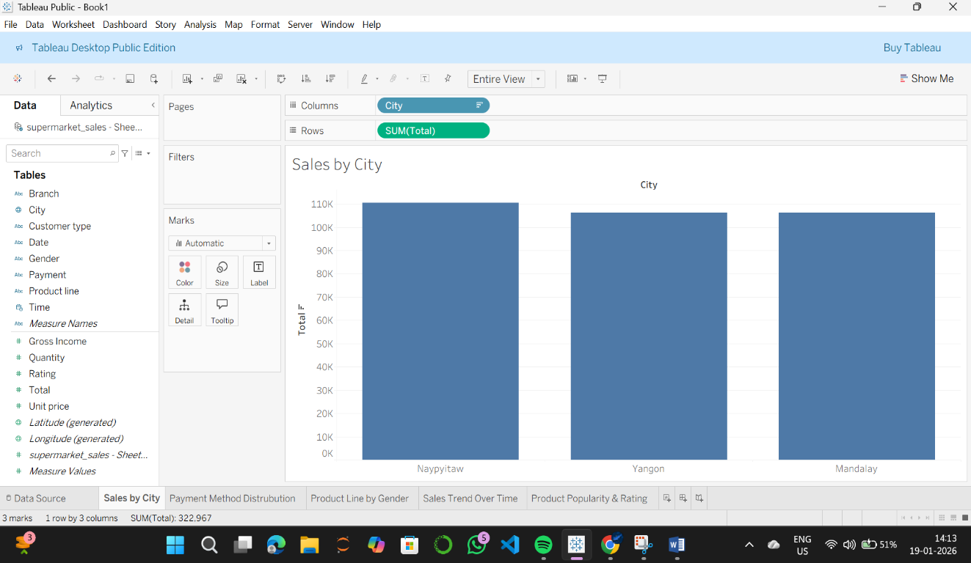
Insight: The data shows that sales are relatively balanced across all three cities, with Naypyitaw showing a slight lead in total revenue.

2. Distribution of Payment Methods (Pie Chart)
This chart illustrates the preference of customers regarding payment options (Cash, E-wallet, and Credit Card).
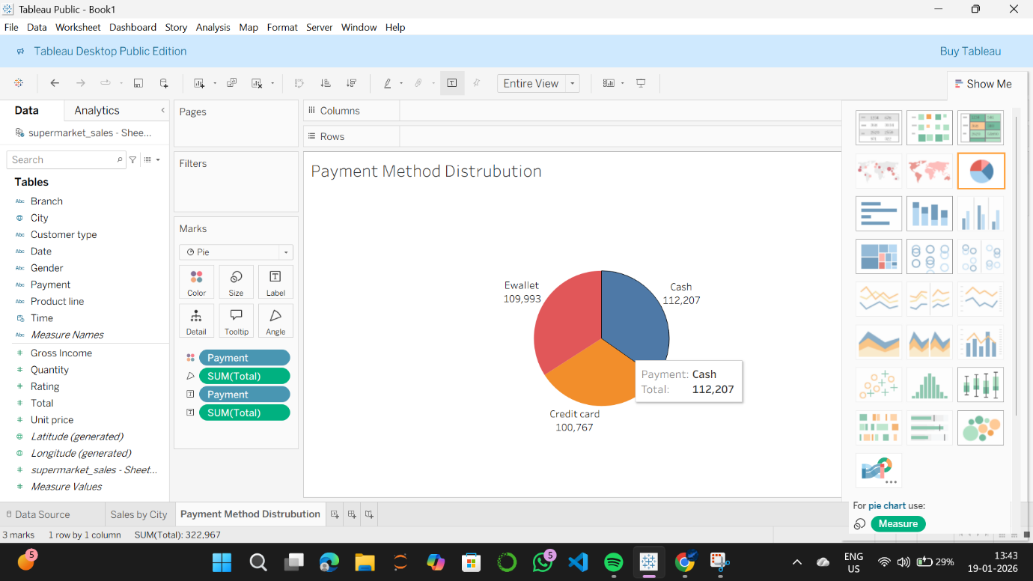
Insight: There is no single dominant payment method; customers use Cash, E-wallets, and Credit Cards almost equally, indicating a flexible payment infrastructure.

3. Sales by Product Line and Gender (Stacked Bar Chart)
This visualization breaks down sales in each product category by the gender of the customer.
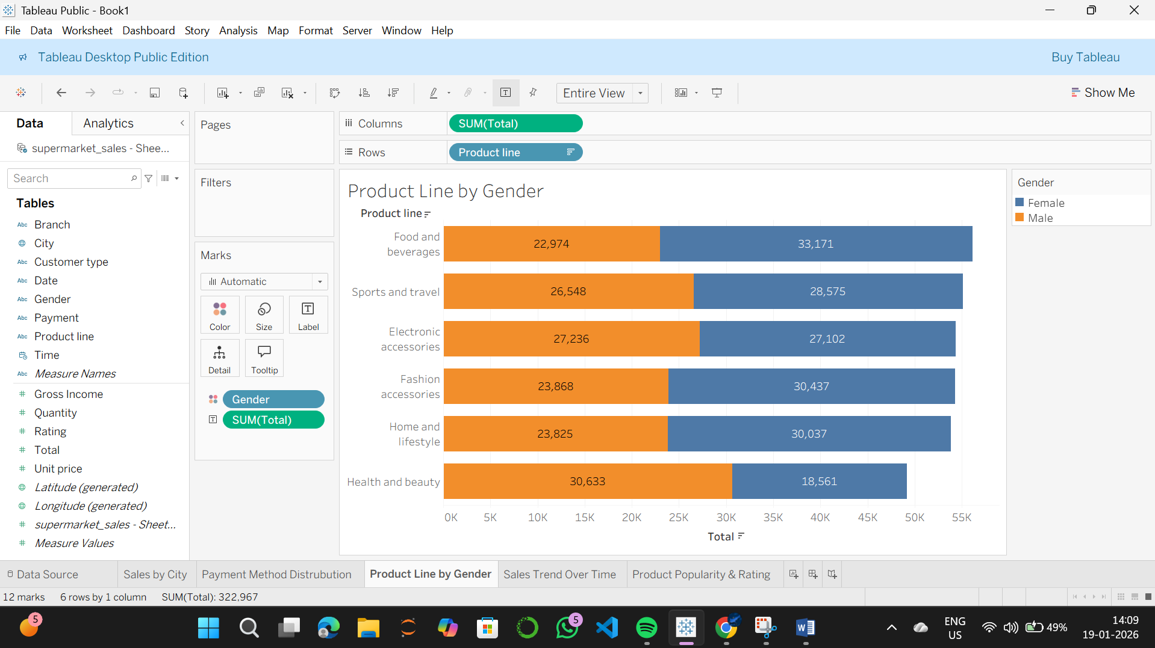
Insight: The chart reveals that while product preferences vary, both male and female customers contribute significantly to the top-performing categories like 'Food and Beverages' and 'Fashion Accessories.

4. Sales Trends Over Time (Line Chart)
This chart tracks the daily total sales from January 2019 to March 2019 to identify growth patterns.
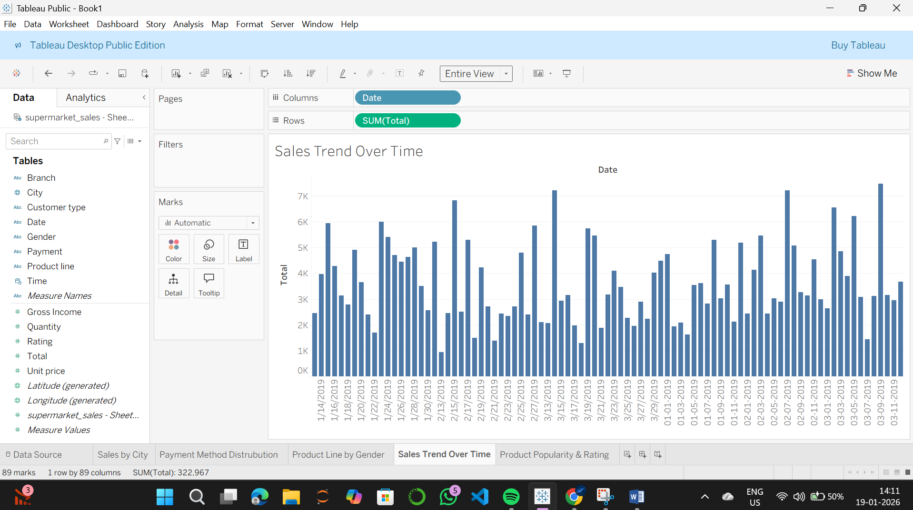
Insight: The trend line shows high volatility with frequent spikes in sales, suggesting that specific days of the week or promotional events drive significant revenue increases.

5. Product Popularity vs. Customer Rating (Bubble Chart)
The size of the bubble represents the quantity sold, while the position/color represents the average customer rating.
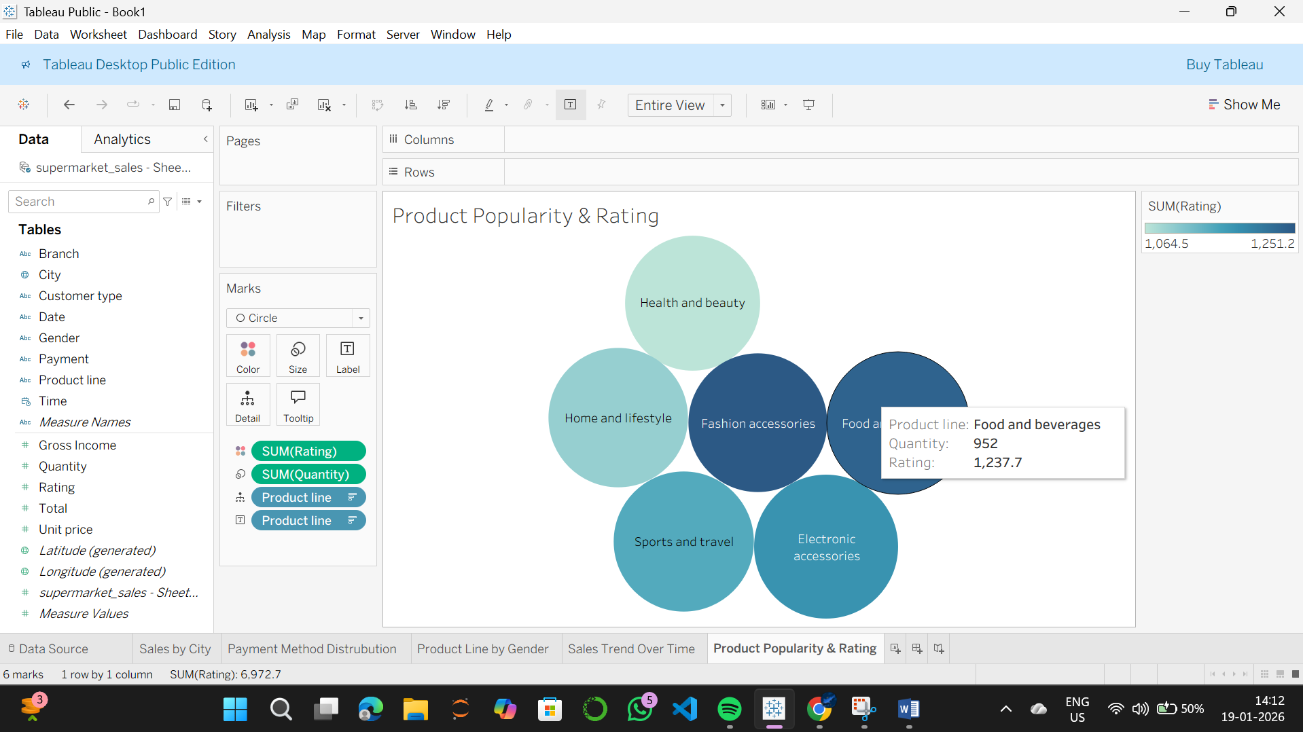
Insight: 'Electronic Accessories' sold the highest volume of items, whereas 'Food and Beverages' achieved the highest average customer satisfaction rating.

